**Name: H_R_S**

**Assignment: 01**

**Question no 01: [5 Marks]**

**Write a Bash Function which returns Factorial of an integer passed as an argument to the script. Returned value must be captured and printed.**

**Code Screen Shot:**

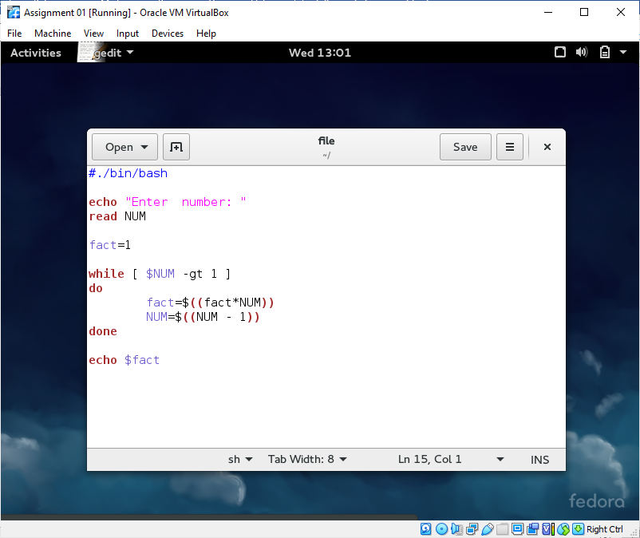

**Code Output Screen Shot:**

